* **[How to export a list from SharePoint](https://sharepoint.rackspace.com/Learning/Articles/Pages/SharePoint-2013--how-to-export-a-list-from-SharePoint.aspx)**

Exporting a SharePoint list to your local computer might not be something you do everyday but it’s good to understand the process. Let's say for example you want to move a SharePoint list from one site collection to another.  You really only have a few lists you want to migrate over and would prefer to use an out of the box feature. Using the list export feature is a very simple and easy way to manually get all of the content in your lists and move it. Keep in mind there are other methods out there to pull content from your SharePoint site but this way is just as effective.  There are few downsides to this method though such as permissions are not retained.   Also certain columns “Created”, “Created by”, “Modified”, and “Modified by” will not retain previous information, it will be updated automatically once the list is moved.  
  
1. From your SharePoint site open any list you would like, in this example I will open **External Contacts**.



2. At the top of the page click **LIST**, to expand the ribbon.

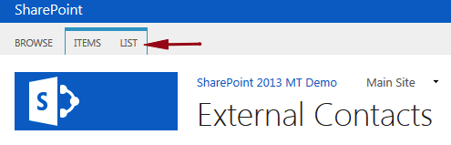

3. In the Connect & Export section click **Export to Excel**.

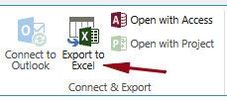

4. From the yellow bar at the bottom click **Open**.

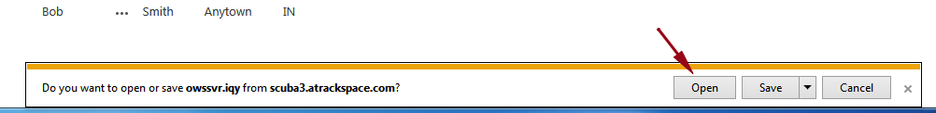

5. On the Microsoft Excel Security Notice pop-up click **Enable**.

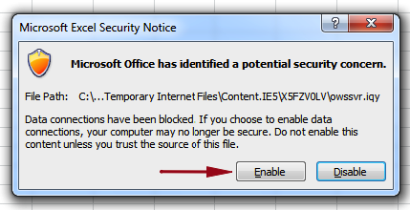

6. The External Contacts list will open and I will see two additional columns Item Type and Path.  Don’t be confused by these as they’re just providing additional information about the items.

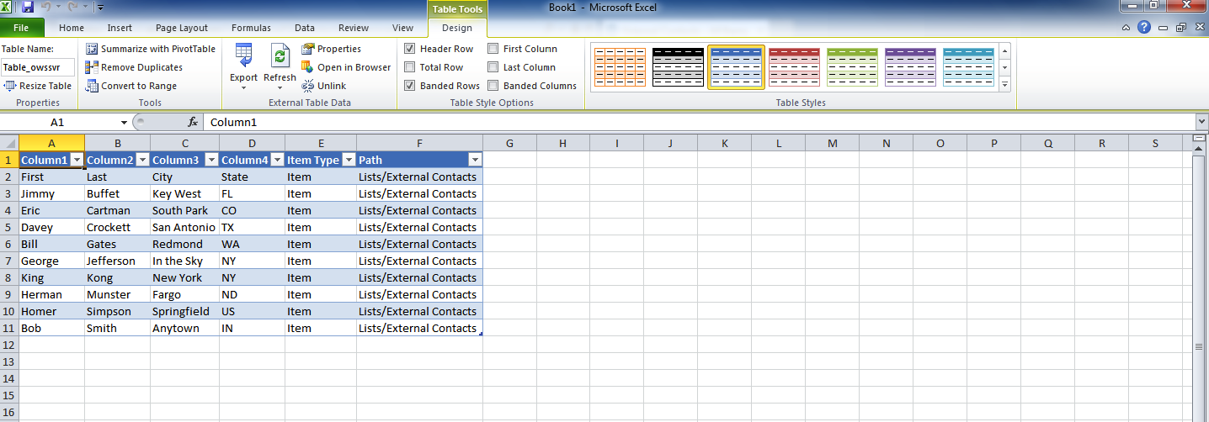

Pretty simple!  Feel free to test this out with other lists on your SharePoint site.